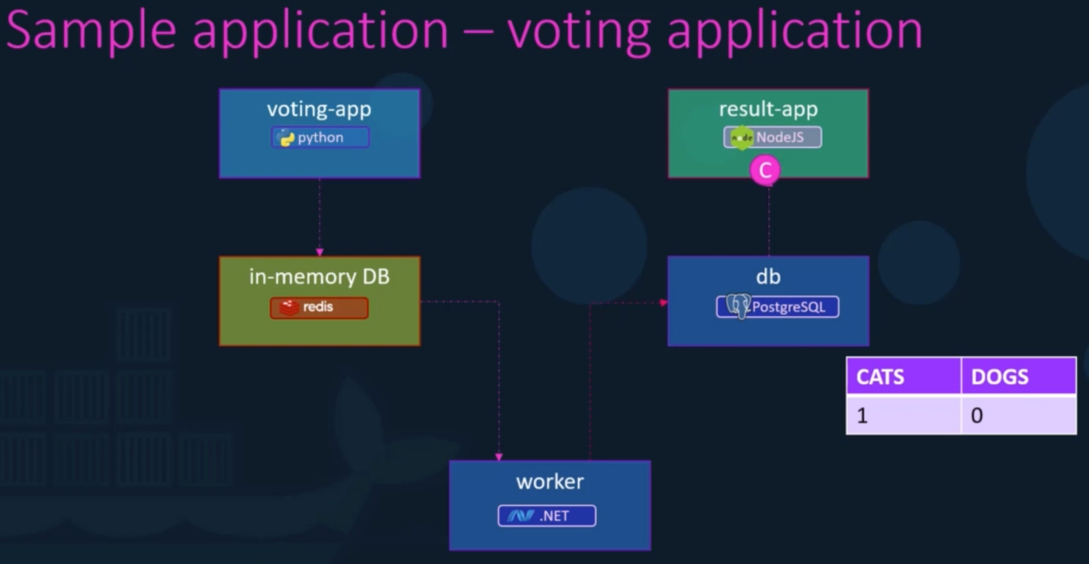

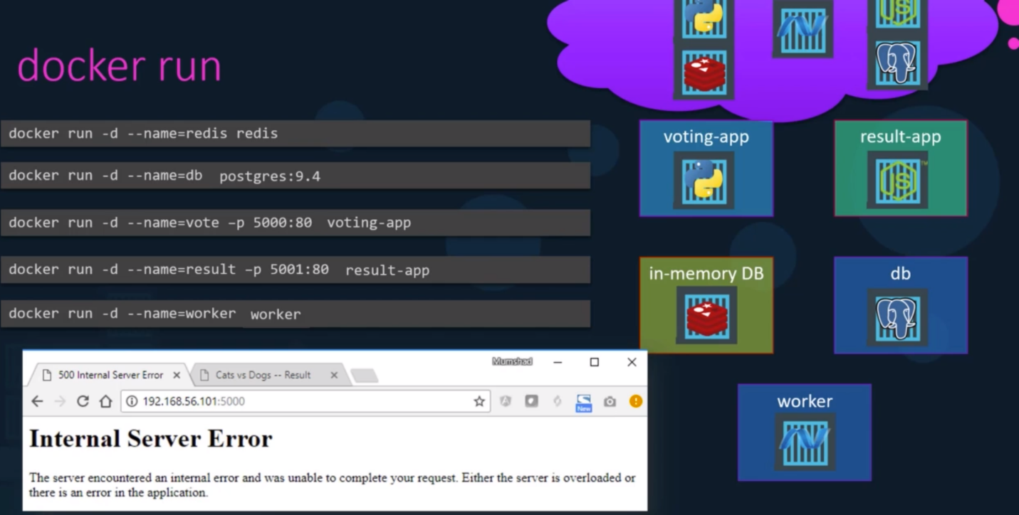

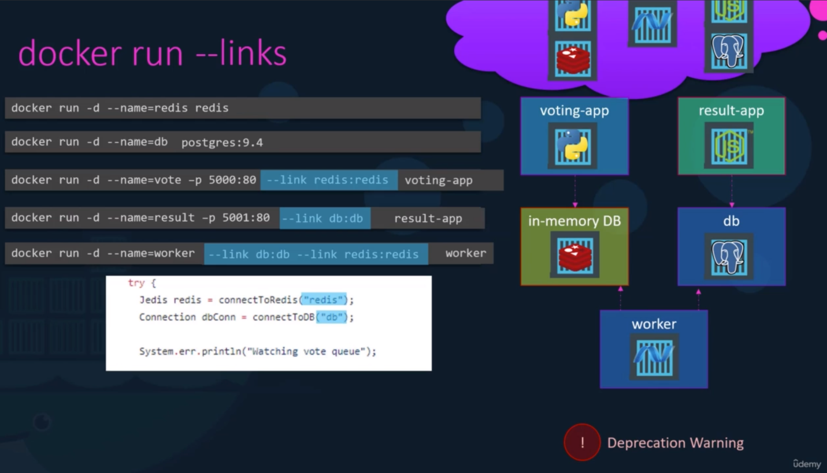

We have a sample Voting application which is used to cast the votes between the Dogs and Cats selection. The application uses different technologies for the communication such as the voting-app is built in python, which uses in-memory DB i.e., Redis Cache, which further is connected to the worker process which is built in .NET and the .NET application uses the Postgres database to save it’s vote and finally the result-app displays the result which is built in Node.js.

As there are variety of technologies involved the communication between all of these applications were made possible only with the help of Docker. And we are using --link tag to actually tell a voting-app to use the Redis container for communication. Similarly, we are linking Redis with worker and result-app with database. Also, remember that **link** could be deprecated in the near future and it is just for the sake of understanding.